# JS Fundamentals: Test Exam

*This is a test exam for course* [*JavaScript Fundamentals*](https://softuni.bg/courses/javascript-fundamentals) *at SoftUni*

## Problem 3. Extractor

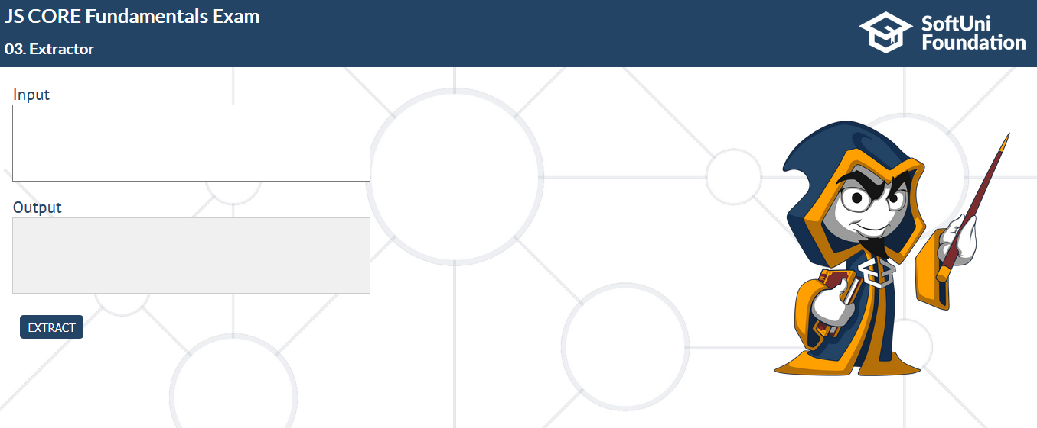

You will receive a single string. It will **start with a number** and that number represents the **count of characters** you need to **take from the string** (**excluding** the **characters of the number**).

Then after you took all the characters you have to see what **character is in the end**. That is the character you need to **split the string by**.

After you have done that, you will get **2 parts**.

* The first part is a **sequence of characters** you need to **remove** from the **second part** and it is a **regex pattern**. More detailed information below.
* In the second part, after you have removed all the characters from the first part, you need to **replace** all the **"#"** with **" "**

Finally, **print what is left from the second string.**

### Example:

Input: **47*0-9%&+I2'm0#a#stu59%d%e&nt#a9t#So00ft%Uni*!+**

First we **take 47 characters** (all of them), then we look at the last character and split by it, so we get these **two strings** **"*0-9%&"** and **"I2'm0#a#stu59%d%e&nt#a9t#So00ft%Uni*!"**.

We create a regex from the first one and we get **"[*0-9%&]"**, we use it on the second string, after that we replace the **"#"** with **" "** and at the end we get: **"I'm a student at SoftUni!"**

### Input/Constrains

* You will receive a single string you need to manipulate
* The input will always be valid

### Output

* When the "**EXTRACT**" button is **clicked**, **print** the **result** into **output** **textarea element.**

### Examples

|  |  |
| --- | --- |
| **Input** | **Output** |
| 47*0-9%&+I0'm0#a#stu99%d%e&nt#a9t#So00ft%Uni*!+ | I'm a student at SoftUni! |
| 67%!3-7=@+Ja45v=aS67cri!pt#Co%@@re#-#Fun4%!d=am6e@5n7t%!als#-#2018+ | JavaScript Core - Fundamentals - 2018 |

